Non-redundant database-

Ref_Seq Database-

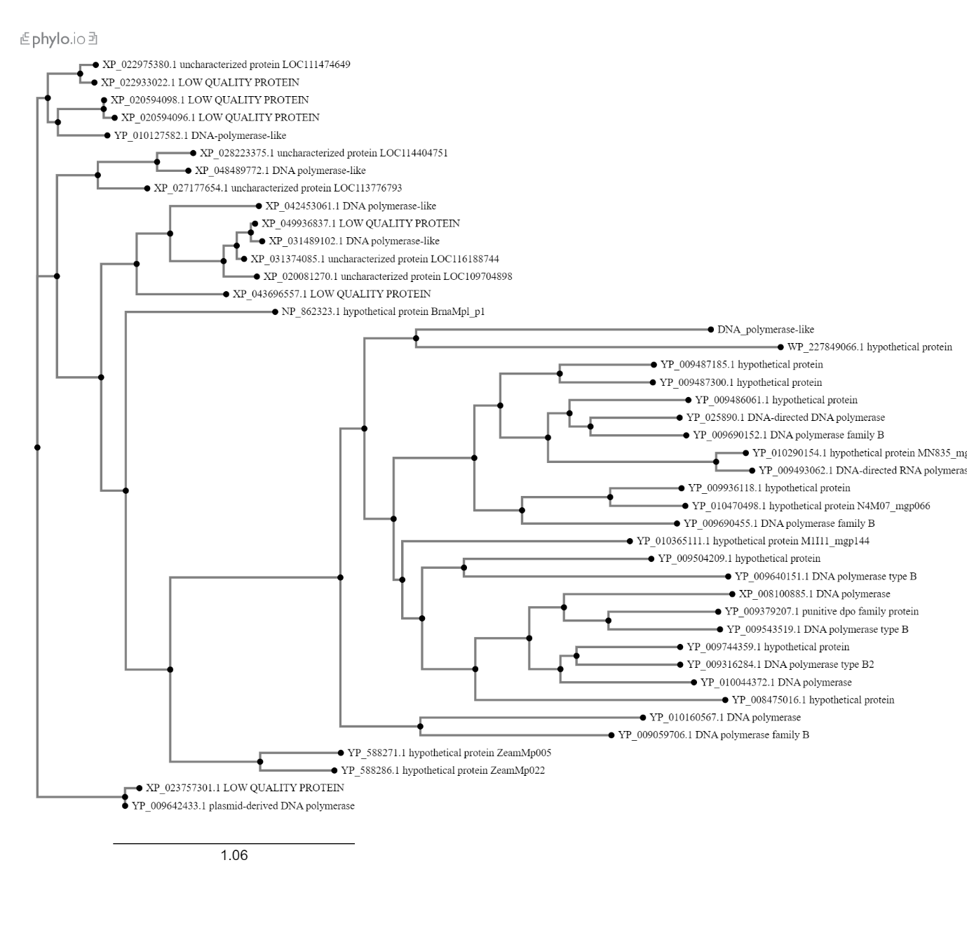

Reference Protein Database-

